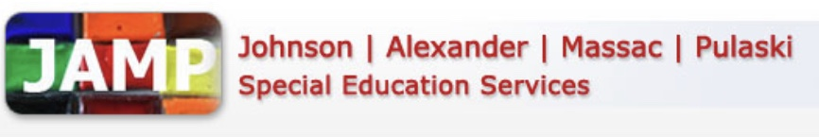

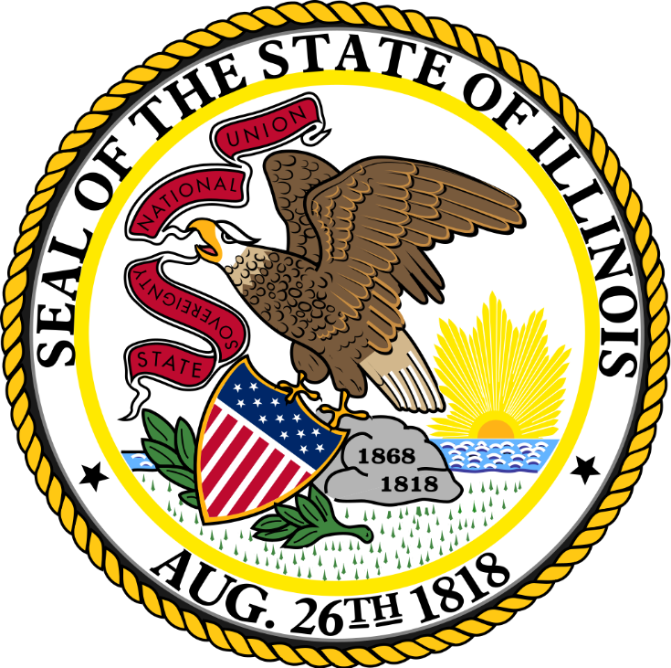

JAMP Special Education Local Wellness Policy

Table of Contents

Preface…………………..…………………………….....………………………………….. 1
Wellness Policy Committee……………………………………………………….… 2
Wellness Policy Leadership…………………….……………………….. 2
Wellness Policy Committee Members………………………………. 2
Wellness Policy Committee Responsibilities…………………....……….….. 3
Public Involvement………………………………………………..…………3
Assessments.………………………………………………………………...… 3
Updates………………….……………………………………………………….. 3
Records………….…………………………………….…………………………. 4
Nutrition……………………………………………………………………….……………. 5
Nutrition Standards………………………………………………………… 5
Nutrition Education................................................................................. 7
Nutrition Promotion……………………..…………………………………. 7
Marketing……………….………………………………………………………. 8
Physical Activity……………………………………………………………………… 9
Physical Education..……………………….…………………………………9
Other Opportunities for Physical Activity......................................9
Physical Activity Promotion……...……..…………….…………………9
Other School-Based Activities……………….……………...……………………. 10

Preface
In accordance with 7 CFR 210.31(c), a Local Education Agency that participates in the National School Lunch Program (NSLP) and/or School Breakfast Program (SBP) must establish a Local School Wellness Policy for all schools under its jurisdiction. As of June 30, 2017, Local Wellness Policies must meet the minimum requirements set forth in the Final Rule: Local School Wellness Policy Implementation Under the Healthy, Hunger-Free Kids Act of 2010.
Local Wellness Policies are a valuable tool in the promotion of student health and wellness through the NSLP and SBP. Schools play an essential role in preparing students for successful futures, and proper nutrition and physical activity are key to creating constructive learning environments. Local Wellness Policies provide guidance to further support schools efforts to provide students with a successful and healthy future.

Wellness Policy Committee

Wellness Policy Leadership
Kim Clayton, Director
Contact: 618-634-9800

Wellness Policy Committee Members

Nora Saxton, Dean of Students

Angela Alexander, Supervisor/Programs Coordinator

Lynn Graves, Teacher

Caroline Hayes, School Psychologist

Hunter Duke, Teacher’s Aide

Wellness Policy Committee Responsibilities

Public Involvement

JAMP Special Education permits and encourages public involvement in Local Wellness Policy development, implementation, updates, and reviews. Therefore, JAMP shall invite a variety of stakeholders within the general public to participate in Local Wellness Policy processes. The following methods of communication will be utilized to notify the general public of the opportunity to participate in these processes:
- JAMP Website https://www.jampsped.org/
- JAMP Facebook page
Assessments
Under the Healthy, Hunger-Free Kids Act of 2010, assessments of the Local Wellness Policy must occur no less than every three years. JAMP Special Education shall conduct assessments of the Local Wellness Policy every three years, beginning in 2010 and occurring every three years thereafter. These assessments will:
- Ensure the wellness policy is in compliance with USDA, State, and Local rules and regulations
- Compare JAMP’s wellness policy to model wellness policies
- Measure the progress made in achieving the goals as outlined in JAMP’s wellness policy

Updates
The Wellness Policy Committee must update the Local Wellness Policy as appropriate in order to fit the needs and goals of the Local Education Agency. JAMP shall make the following available to the public:
- The Local Wellness Policy, including any updates to the policy, on a yearly basis
- The triennial assessment, including progress toward meeting the goals outlined in the wellness policy
Through the following channels:
- JAMP Website https://www.jampsped.org/

Records
JAMP shall maintain record of the Local Wellness Policy. This includes keeping a copy of the current wellness policy on file and maintaining documentation of the following actions:
- The most recent assessment of the policy
- Availability of the wellness policy and assessments to the public
- Reviews and revisions of the policy, including the individuals involved and the efforts made to notify stakeholders of their ability to participate in the process

Nutrition
JAMP recognizes the important role nutrition plays in academic performance as well as overall quality of life. The National Education Association references numerous articles supporting the effects of nutrition on the classroom, for example, hunger often has a negative impact on students’ success, attendance, and behavior.
According to the Centers for Disease Control and Prevention, approximately 18.5 percent of the nation’s youth was considered obese in 2015-16. This percentage increased 1.3 percent when compared to the previous year. Conversely, 15.7 percent of American families experienced food hardship in 2017. Through participation in the U.S. Department of Agriculture’s School Nutrition Programs, JAMP commits to serving nutritious meals to students in order to prevent both overconsumption of nutrient-poor foods and food insecurity to give students the best chance to succeed inside and outside the classroom.
Nutrition Standards
Meals
Students at the JAMP River to River Center will be offered and schools will promote nutritious food and beverage choices consistent with the current Dietary Guidelines for Americans and Food Guidance System published jointly by the U.S. Department of Health and Human Services and the Department of Agriculture. Reimbursable school meals served shall meet, at a minimum, the nutrition requirements and regulations for the National School Lunch Program and/or School Breakfast Program.
All reimbursable meals served for the purposes of the National School Lunch Program (NSLP) and School Breakfast Program (SBP) must meet or exceed USDA nutrition standards and regulations. This includes meeting standards for each of the meal pattern components (i.e. Grains, Meat/Meat Alternates, Fruits, Vegetables, and Milk) as well as meeting or exceeding the limitations set for calories, sodium, saturated fat, and trans fat.
Competitive Foods
In order to promote student health and reduce childhood obesity, the Director or designee shall establish such administrative procedures to control food sales that compete with the District’s non-profit food service in compliance with the Child Nutrition Act. Food service rules shall restrict the sale of foods of minimal nutritional value as defined by the U.S. Department of Agriculture in the school.
All competitive foods and beverages sold must comply with the USDA Smart Snacks in Schools nutrition standards (7 CFR 210.31(c)(3)(iii)). Competitive foods and beverages refer to those that are sold to students outside the reimbursable meal on the school campus (i.e. locations on the school campus that are accessible to students) during the school day (i.e. the midnight before to 30 minutes after the end of the school day). This includes, but is not limited to, vending machine and à la carte items.

Other Foods and Beverages
- The following policy refers to all foods and beverages provided, but not sold to students. JAMP will prohibit the use of food as a reward or as part of a celebration. Providing alternatives to food as a reward promotes healthier habits by reducing exposure to less nutritious food items and, therefore, the amount of calorie-dense food items consumed (e.g. cakes, cookies, candy, etc.). This helps children develop improved food preferences and hunger cues to carry them throughout life. Instead, schools will implement the following methods for rewards and celebrations:

- The following policy refers to all foods and beverages provided, but not sold to students. JAMP will prohibit food and beverage items that do not meet Smart Snacks nutrition standards for reward and celebration purposes. More than 25 percent of children’s daily calories may come from snacks, therefore, providing Smart Snacks allows for a more nutrient-dense calorie intake.
Fundraisers

- All fundraisers promoting food and/or beverage items that are held on school campus (i.e. locations on the school campus that are accessible to students) during the school day (i.e. the midnight before to 30 minutes after the end of the school day) must meet Smart Snacks nutrition standards.
JAMP shall also utilize non-food fundraisers to promote healthy habits and well-being. JAMP will implement the following non-food fundraising ideas:

- Fundraisers promoting food and/or beverage items that are held on school campus (i.e. locations on the school campus that are accessible to students) during the school day (i.e. the midnight before to 30 minutes after the end of the school day) must meet Smart Snacks nutrition standards. However, JAMP may participate in infrequent exempted fundraising days, in which food and beverage items do not meet Smart Snacks standards, as JAMP sees fit. These exempted fundraising days shall not exceed nine days within one year. JAMP shall comply with the following procedures when managing exempted fundraising days:

- JAMP Special Education does not utilize any fundraisers.

Nutrition Education
In accordance with the Illinois Learning Standards, JAMP shall meet all Illinois requirements and standards for Health Education. JAMP shall include nutrition education within the health education curriculum and integrate nutrition education into other core subjects, as appropriate. Various grade levels and curriculums shall use nutrition education information, research, and materials from the following resources:
- Dietary Guidelines for Americans, MyPlate, Team Nutrition, and FoodMASTER .
JAMP shall incorporate nutrition education into the following curriculums for the following grade levels:
- Nutrition education will be included in health education and physical education classes.
Nutrition Promotion
JAMP shall implement nutrition promotion techniques through multiple channels, including the cafeteria, classroom, and home.
JAMP shall make cafeteria menus and nutrition information available through the following platforms:
- Menus will be posted in the school and on the JAMP Facebook page

Farm to School efforts positively impact School Nutrition Programs by serving fresh and nutritious food items. Additionally, Farm to School programs have been linked to increased consumption of fruits and vegetables. JAMP shall participate in the following Farm to School activities:
- The students may choose to participate in projects to assist with growing fruits or vegetables.
Food loss and waste continue to be an issue facing the nation’s food supply. In order to prevent food waste, JAMP will make every effort to produce the precise number of meals needed on any given day by using production records and resources such as the USDA’s Food Buying Guide. However, in the event excess food remains, the District will continue to provide food to students in need beyond the meals provided through the USDA School Nutrition Programs. Therefore, the District shall follow the established food sharing plan, in accordance with Public Act 102-0359, and federal and local regulations and sanitation codes:
- Meals for JAMP students come from Century School District. A JAMP staff member notifies Century of the number of meals needed each day based upon actual attendance. There is no food waste.

Marketing

JAMP will prohibit the marketing and advertising of all foods and beverages that do not meet Smart Snacks nutrition standards on the school campus (i.e. locations on the school campus that are accessible to students) during the school day (i.e. the midnight before to 30 minutes after the end of the school day). The marketing standards described above apply, but are not limited to, oral, written, and graphic statements made for promotional purposes. Items subject to marketing requirements include, but are not limited to, posters, menu boards, vending machines, coolers, trash cans, scoreboards, and other equipment. This policy does not require schools to immediately replace equipment that does not meet this requirement, however, JAMP shall implement these standards as equipment needs replaced in the future.

Physical Activity
Physical activity is a key component of the health and well-being of all students. Physical activity lowers the risk for certain diseases, including obesity, heart disease, and diabetes. Physical activity also helps improve brain function, allowing students to perform better in school.
The Centers for Disease Control and Prevention recommends adolescents get at least 60 minutes of physical activity five days per week. Nearly 79 percent of school-age children fall short of meeting this requirement. JAMP recognizes this connection and commits to promoting and providing opportunities for physical activity during and outside the school day.
Physical Education
In accordance with the Illinois Learning Standards, JAMP shall meet all Illinois requirements and standards for Physical Education. JAMP shall offer Physical Education class as follows:
- Students will participate in physical education daily

Other Opportunities for Physical Activity
The District shall include additional physical activity opportunities, outside of Physical Education class, during the school day through the following:
- Students will participate in recess, brain breaks, and reward time in the workout room
The following opportunities for participation in school-based sports shall be offered to students each year:
- All student opportunities for school-based sports will be offered through the student’s home district.
Physical Activity Promotion
Goals for Physical Activity:

- JAMP will support and promote an active lifestyle for students.
- Physical education will be taught in all grades and shall include a developmentally planned and sequential curriculum that fosters the development of movement skills, enhances health-related fitness, increases students’ knowledge, offers direct opportunities to learn how to work cooperatively in a group setting, and encourages healthy habits and attitudes for a healthy lifestyle.
- Unless otherwise exempted, all students will be required to engage daily during the school day in a physical education course.
- The curriculum will be consistent with and incorporate relevant Illinois Learning Standards for Physical Development and Health as established by the Illinois State Board of Education.

Other School-Based Activities
Just as it takes a comprehensive curriculum to provide education to support students’ futures, JAMP’s wellness approach must also be comprehensive in its intent to provide students with the tools they need to live a healthy lifestyle. In order to further establish positive behaviors related to nutrition, physical activity, and health, JAMP commits to making additional wellness-based activities available to all students beyond the cafeteria and gymnasium.
JAMP shall offer other school-based activities to support student health and wellness, including coordinated events and clubs. The following events shall be organized and promoted each year:
- Students will be able to participate in class activities and competitions including Just Dance competitions, staff vs. students activities, and other organized events.

